Go to SE11

**In the below example, all fields are based on Data Element.**

**The Data Element is based on Domain.**

**Note: If the objects, such as tables, data elements, domain are already present, You can**

* 1. **Create New**
  2. **Delete the objects (only if you have created it) and then recreate it**
  3. **If the table is already created with the data elements, just use the same table to create domain**

1. Create table with the name as ZXXXXXXDEPT2.
2. Give delivery class as A and Display/Maintenance Allowed.
3. For the field MANDT, give data element as MANDT
4. For Field, Deptno, mention Data Element as ZXXXXXXDEDEPTNO.

Where XXXXXX is your empcode.

1. Double click on the data element ZXXXXXXDEDEPTNO.

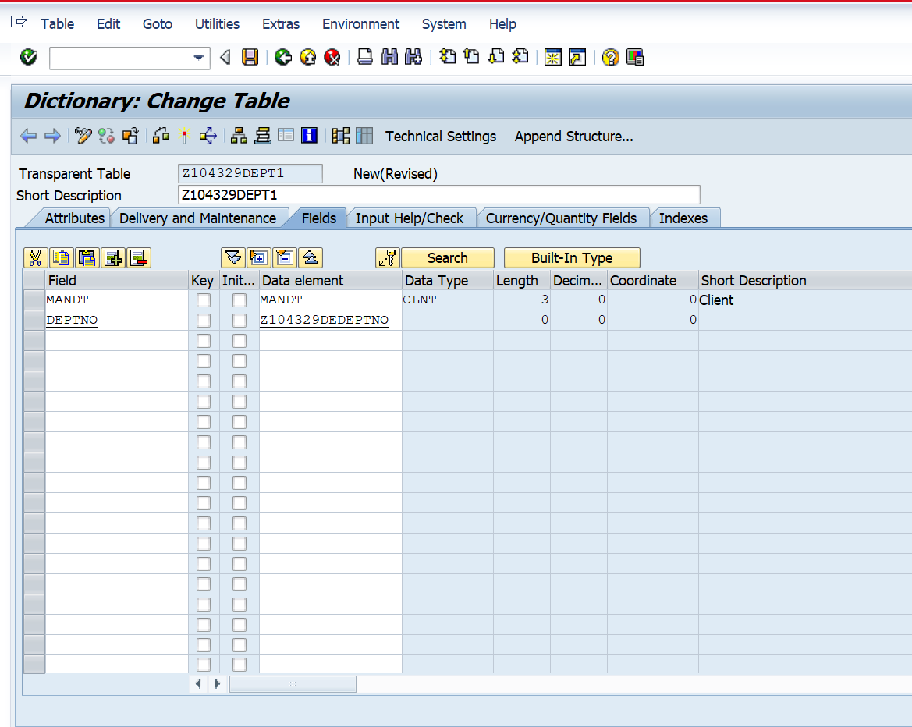

1. The following dialog box is displayed, click yes.

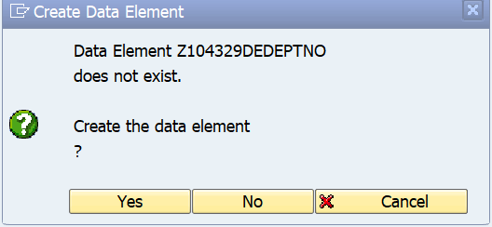

1. The Data Element is based on Domain. Mention Domain name as Element as ZXXXXXXDOMDEPTNO. The domain is NOT already present.

Double click on Domain Name.

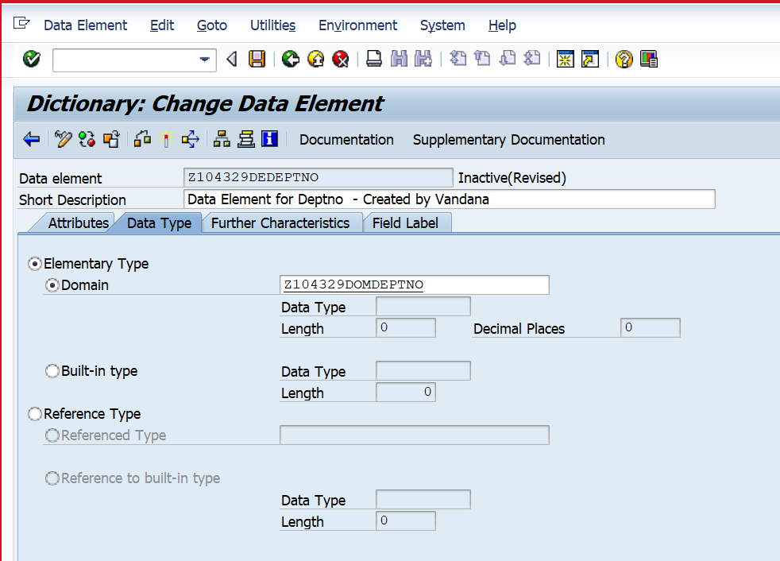

Create the domain.

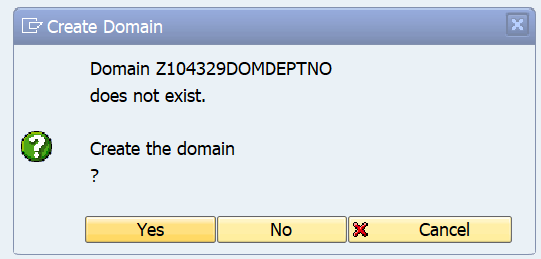

1. Select data type and length as shown below.

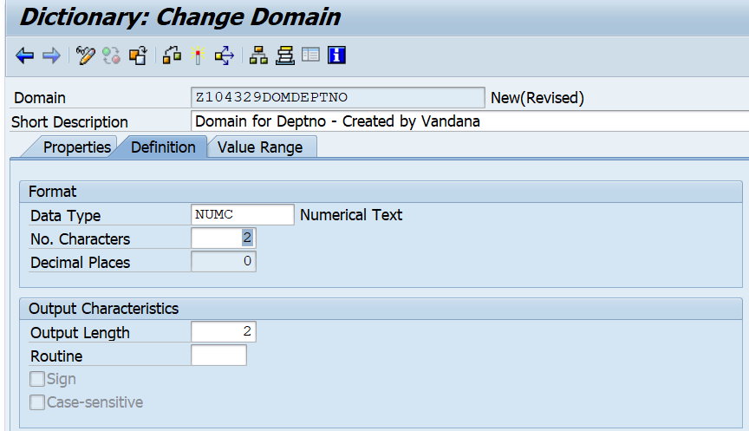

Giving Value Range for Domain.

Go to the Domain. Enter values as shown below.

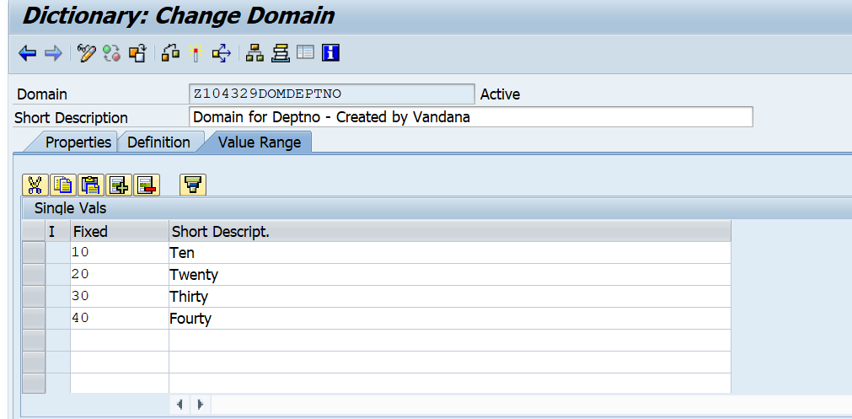

1. Save and activate the domain. Go back.
2. Enter Field Labels for Data Element as shown below.

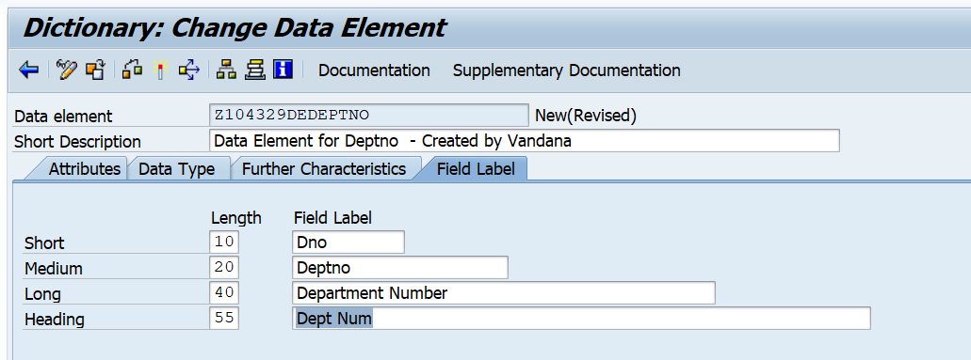

1. Click on documentation For Data Element. Enter documentation as shown below.

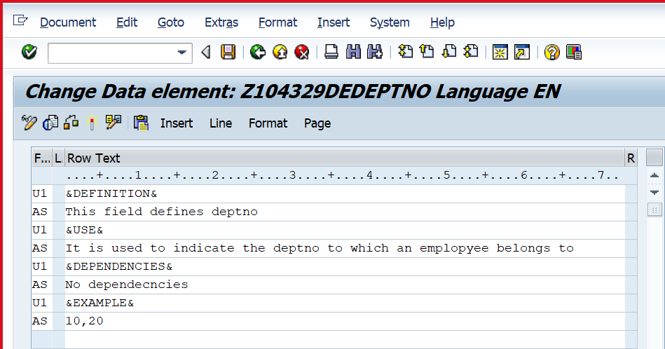

1. Save. Go back.
2. Activate the Data Element.
3. Go back. You will see screen as below which shows that the data element has been created.

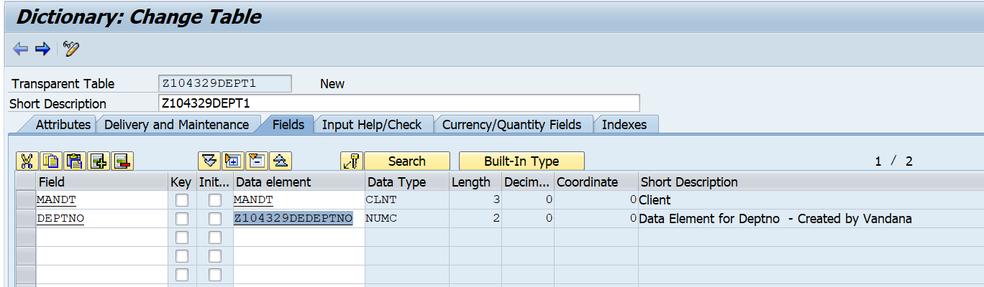

1. Similarly create the remaining two fields as shown below with appropriate field labels and documentation.
2. Give Primary keys, as shown below.
3. Save and Activate the table.

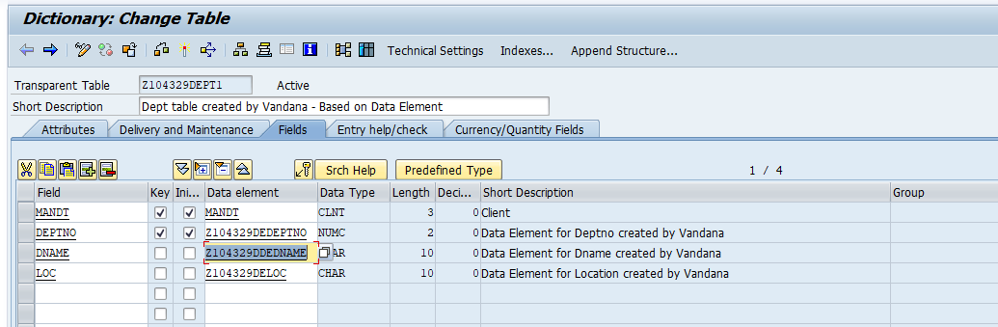

Save and activate the domain.

Go back.

Save and activate the data element.

Activate the table.

Go to Utilities – Table Contents – Create entries.

Select values for deptno field. You will observe that you can see long field label here.

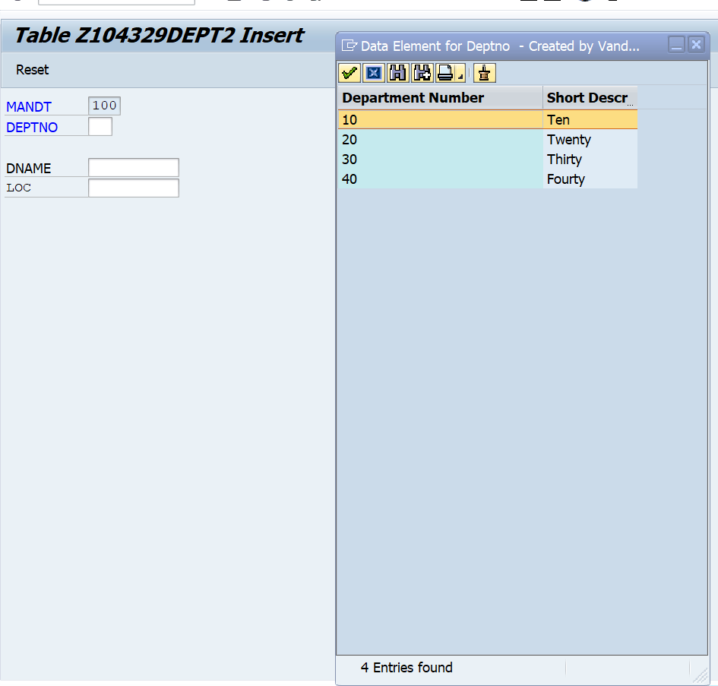

Enter Records in the table as shown below.

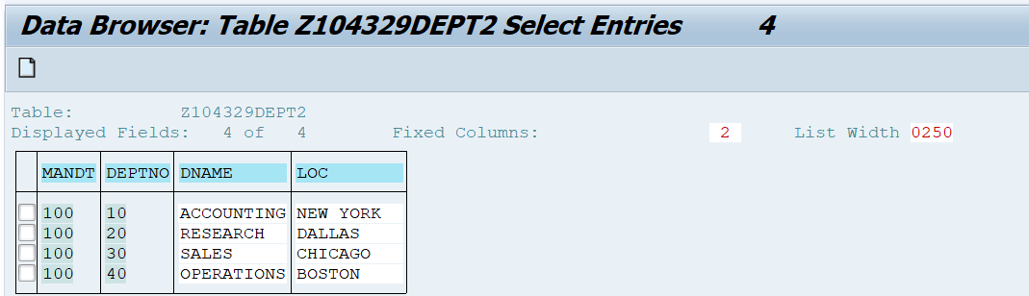

Use in SE38 pgm

REPORT Z.  
  
PARAMETERS DEPTNO TYPE Z104329DEPT-DEPTNO.  
PARAMETERS DEPTNO1 TYPE Z104329DEDEPTNO.  
  
WRITE DEPTNO.  
WRITE DEPTNO1.